**Project Title : A CRM Application for Car Rentals**

**Name: Pranay Ashokrao Pohokar**

**Email:** [**pohokarpranay@gmail.com**](mailto:pohokarpranay@gmail.com)

**Skillwallet ID: SWUID20240040361**

**1. Project Overview**

A CRM Application for Car Rentals is designed to streamline the entire vehicle rental process, delivering cars seamlessly to customers while enhancing their overall experience. By harnessing the power of advanced customer relationship management (CRM), the application not only boosts customer satisfaction but also optimises fleet management, reservation systems, and day-to-day rental operations. What sets it apart is its ability to drive effective customer engagement using personalised email communication with potential customers, identified through data driven insights, to build strong relationships and foster long-term loyalty. This holistic approach ensures improved efficiency, higher retention rates, and a superior customer experience.

### **2. Objectives**

**Business Goals:**

* **Enhance Customer Satisfaction**: Improve customer experience by providing seamless car rental services through a user-friendly CRM application.
* **Increase Revenue**: Boost revenue by increasing customer retention and attracting new clients through personalised communication and data-driven marketing strategies.
* **Optimise Operations**: Streamline rental operations, including reservation management, fleet tracking, and billing processes, to enhance overall efficiency and reduce operational costs.
* **Build Customer Loyalty**: Leverage CRM tools to foster long-term relationships with customers, encouraging repeat business through personalised offers and tailored services.

**Specific Outcomes:**

* **Automated Reservation Management**: Implement a system that allows for automated booking, confirmation, and cancellation of car rentals, reducing manual intervention.
* **Targeted Email Campaigns**: Deliver personalised email campaigns to potential and existing customers, improving engagement and conversion rates.
* **Real-time Fleet Management**: Provide real-time tracking and management of vehicle availability, usage, and maintenance status, ensuring efficient utilisation of the fleet.
* **Comprehensive Customer Profiles**: Build detailed customer profiles that include rental history, preferences, and feedback, enabling personalised service and tailored recommendations.
* **Enhanced Reporting**: Generate actionable insights through data analytics on customer behaviour, rental trends, and operational efficiency for continuous improvement.

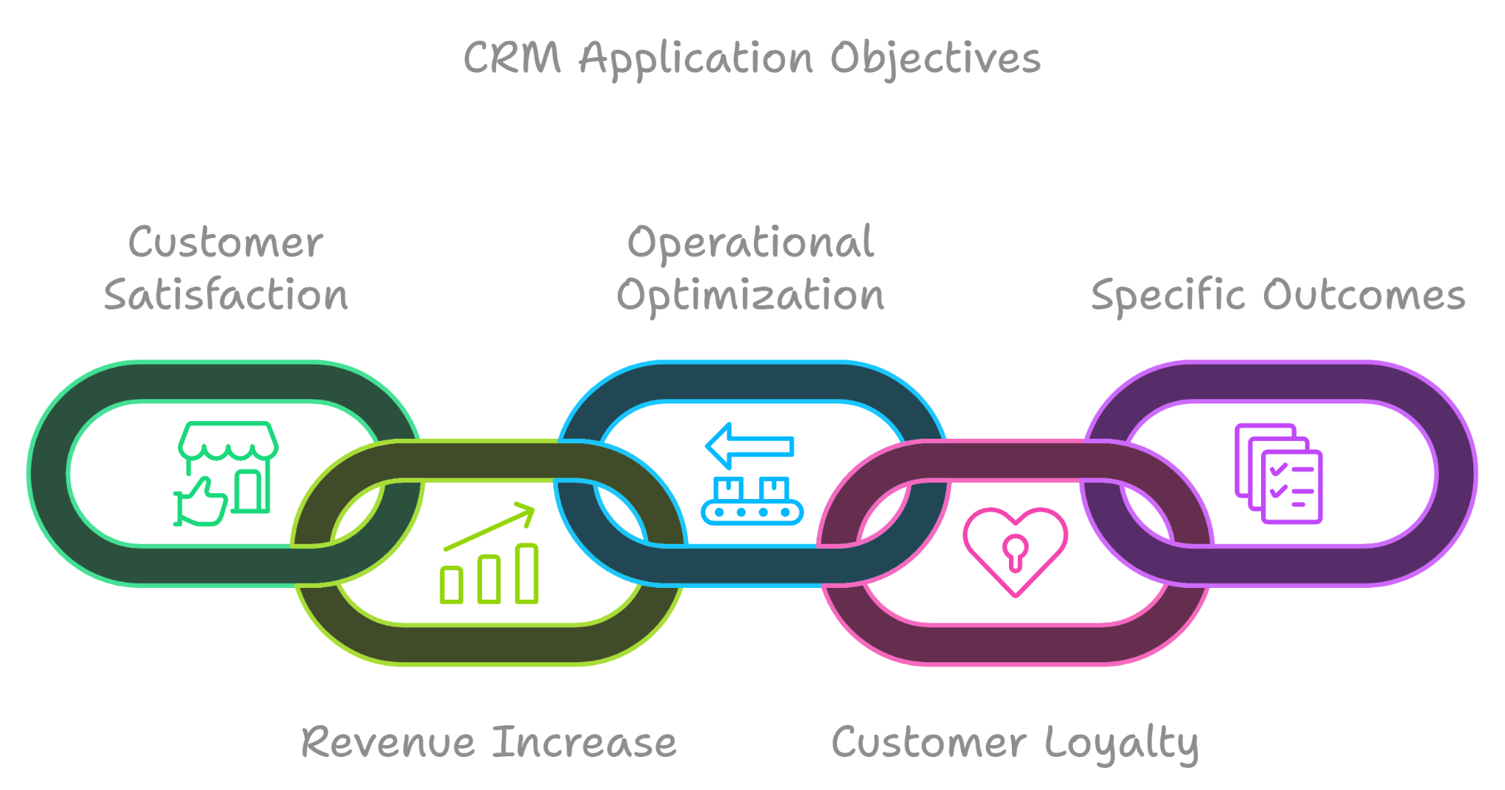

**3. Salesforce Key Features and Concepts Utilized**

### **Object Creation**

**What Is an Object?**Salesforce objects are database tables that permit you to store data that is specific to an organization. What are the types of Salesforce objects  
Salesforce objects are of two types:

1. **Standard Objects:** Standard objects are the kind of objects that are provided by salesforce.com such as users, contracts, reports, dashboards, etc.
2. **Custom Objects:** Custom objects are those objects that are created by users. They supply information that is unique and essential to their organization. They are the heart of any application and provide a structure for sharing data.

### **Create Total Cars Object**

1. From the setup page >> Click on Object Manager >> Click on Create >> Click on Custom Object.

1) Enter the label name>> Total Cars

2) Plural label name>> Total Cars

3) Enter Record Name Label and Format

Record Name >>Total Cars

Data Type >> Text

1. Click on Allow reports,Allow search and Track Field History,
2. Save.

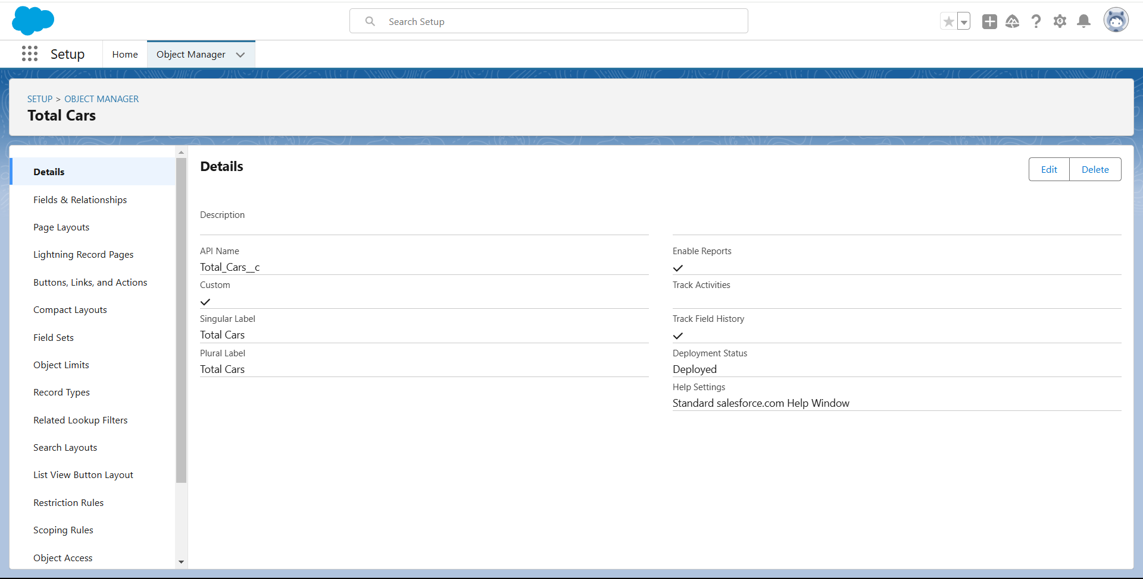

### **Create consumer Object**

From the setup page >> Click on Object Manager >> Click on Create >> Click on Custom Object.

1) Enter the label name >> consumer

2) Plural label name >> consumer

3) Enter Record Name Label and Format

Record Name >> consumer_name

Data Type >> Name

1. Click on Allow reports,Allow search and Track Field History,
2. Save.

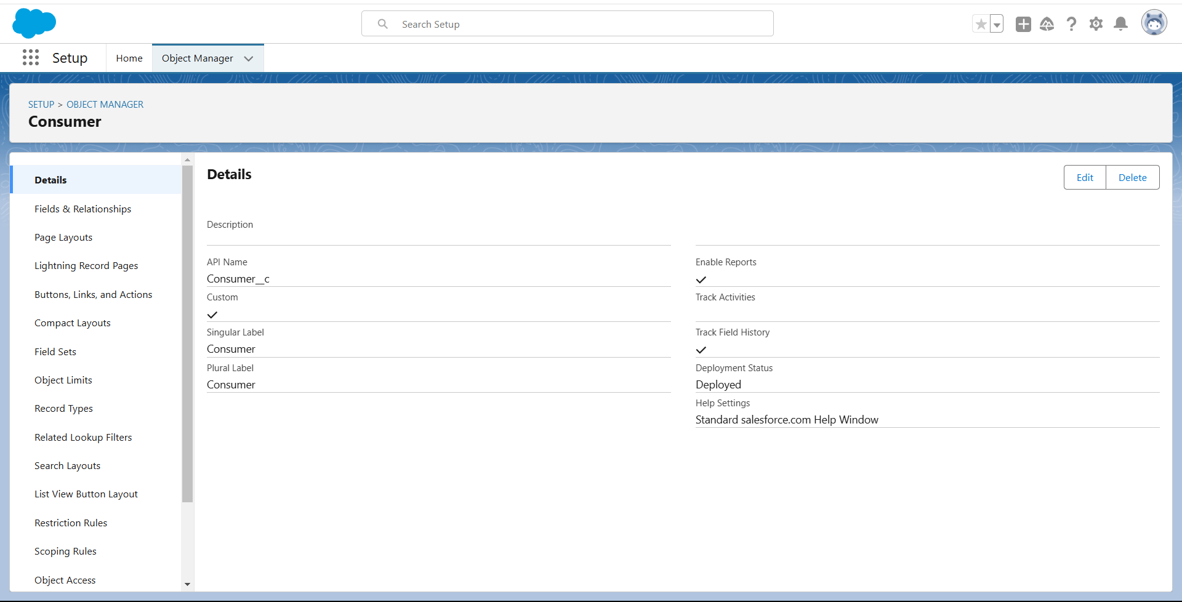

### **Create Car Bookings Object**

From the setup page >> Click on Object Manager >> Click on Create >> Click on Custom Object.

1) Enter the label name >> Car Bookings

2) Plural label name >> Car Bookings

3) Enter Record Name Label and Format

Record Name >> Car Bookings

Data Type >> Name

1. Click on Allow reports,Allow search and Track Field History,
2. Save.

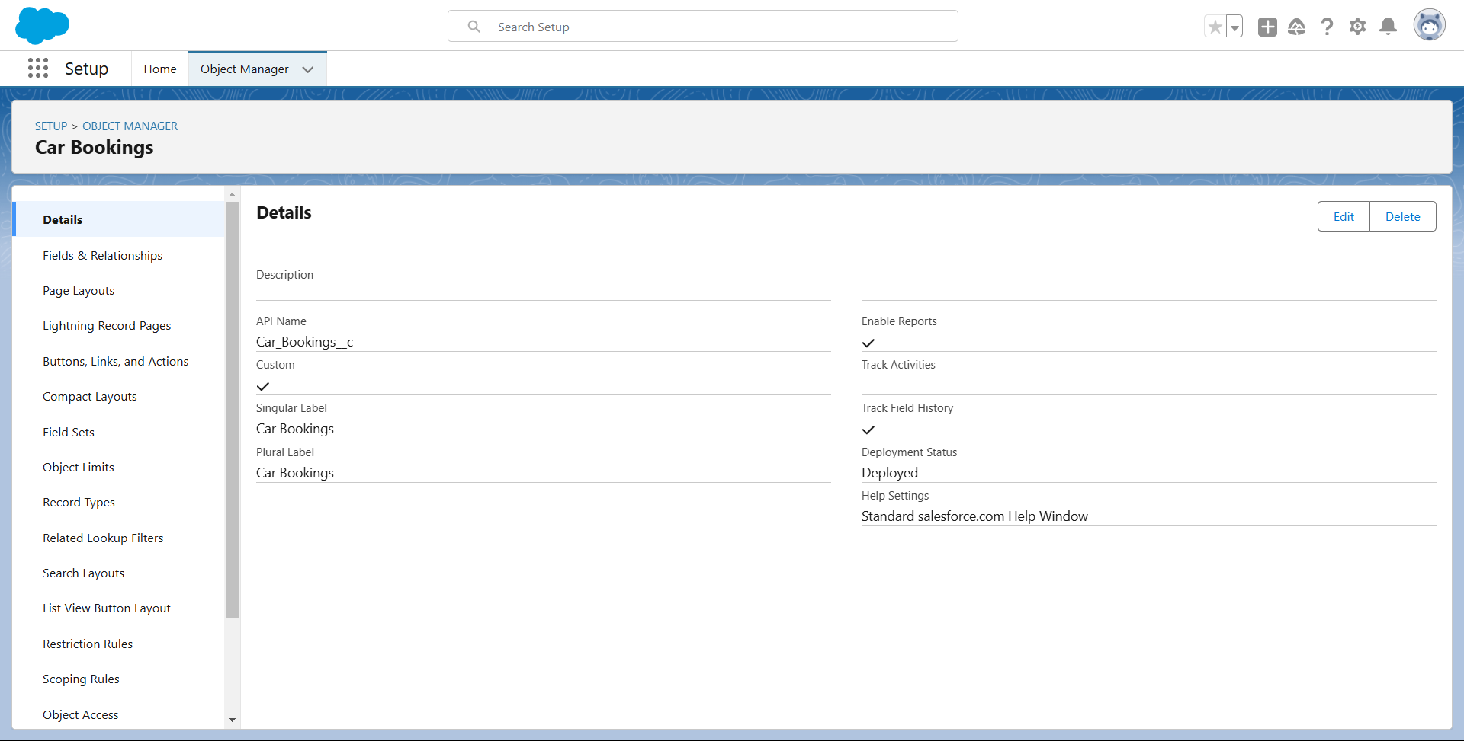

### **Create Billing Process Object**

From the setup page >> Click on Object Manager >> Click on Create >> Click on Custom Object.

1) Enter the label name >> Billing Process

2) Plural label name >> Billing Process

3) Enter Record Name Label and Format

Record Name >> Billing ProcessName

Data Type >> Name

1. Click on Allow reports,Allow search and Track Field History,
2. Save**.**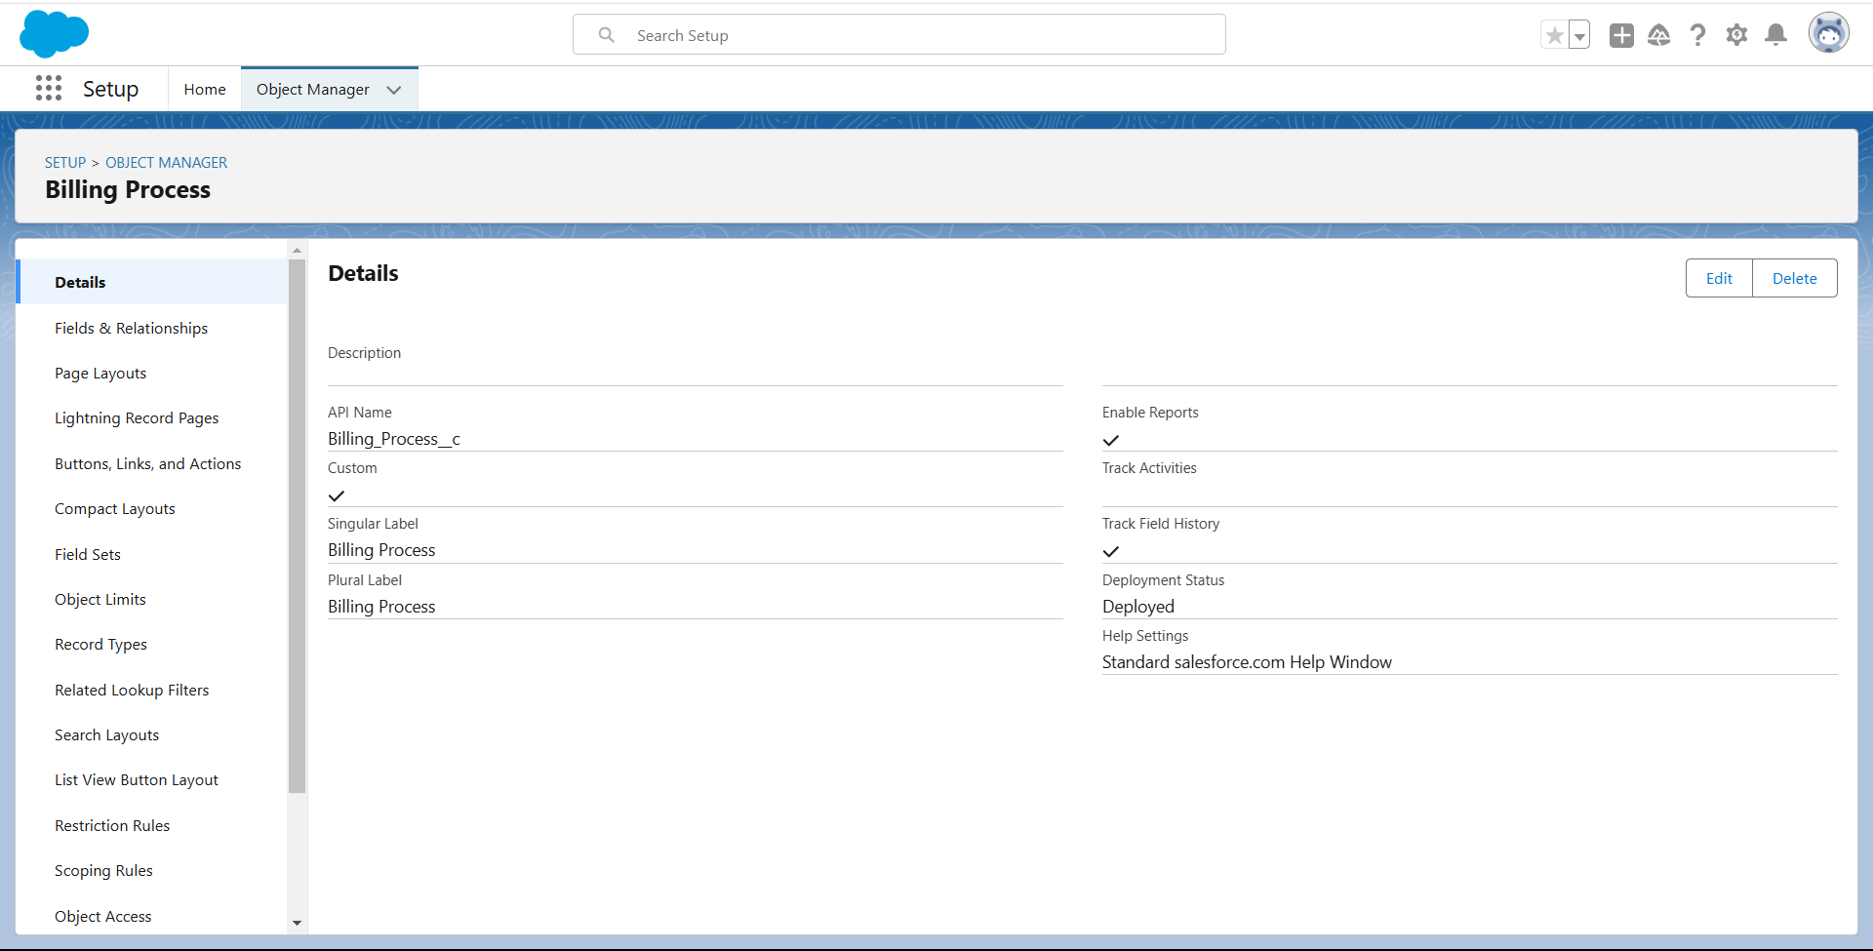

### **Tabs**

**What is Tab : A tab is like a user interface that is used to build records for objects and to view the records in the objects.**

**Types of Tabs:**

1. **Custom Tabs:** Custom object tabs are the user interface for custom applications that you build in salesforce.com. They look and behave like standard salesforce.com tabs such as accounts, contacts, and opportunities.
2. **Web Tabs:** Web Tabs are custom tabs that display web content or applications embedded in the salesforce.com window. Web tabs make it easier for your users to quickly access content and applications they frequently use without leaving the salesforce.com application.
3. **Visualforce Tabs:** Visualforce Tabs are custom tabs that display a Visualforce page. Visualforce tabs look and behave like standard salesforce.com tabs such as accounts, contacts, and opportunities.
4. **Lightning Component Tabs:** Lightning Component tabs allow you to add Lightning components to the navigation menu in Lightning Experience and the mobile app.
5. **Lightning Page Tabs:** Lightning Page Tabs let you add Lightning Pages to the mobile appnavigation menu.

Lightning Page tabs don't work like other custom tabs. Once created, they don't show up on the All Tabs page when you click the Plus icon that appears to the right of your current tabs. Lightning Page tabs also don't show up in the Available Tabs list when you customize the tabs for your apps.

### 

### 

### 

### 

### 

### **Creating a Custom Tab**

**Car Bookings Tab**

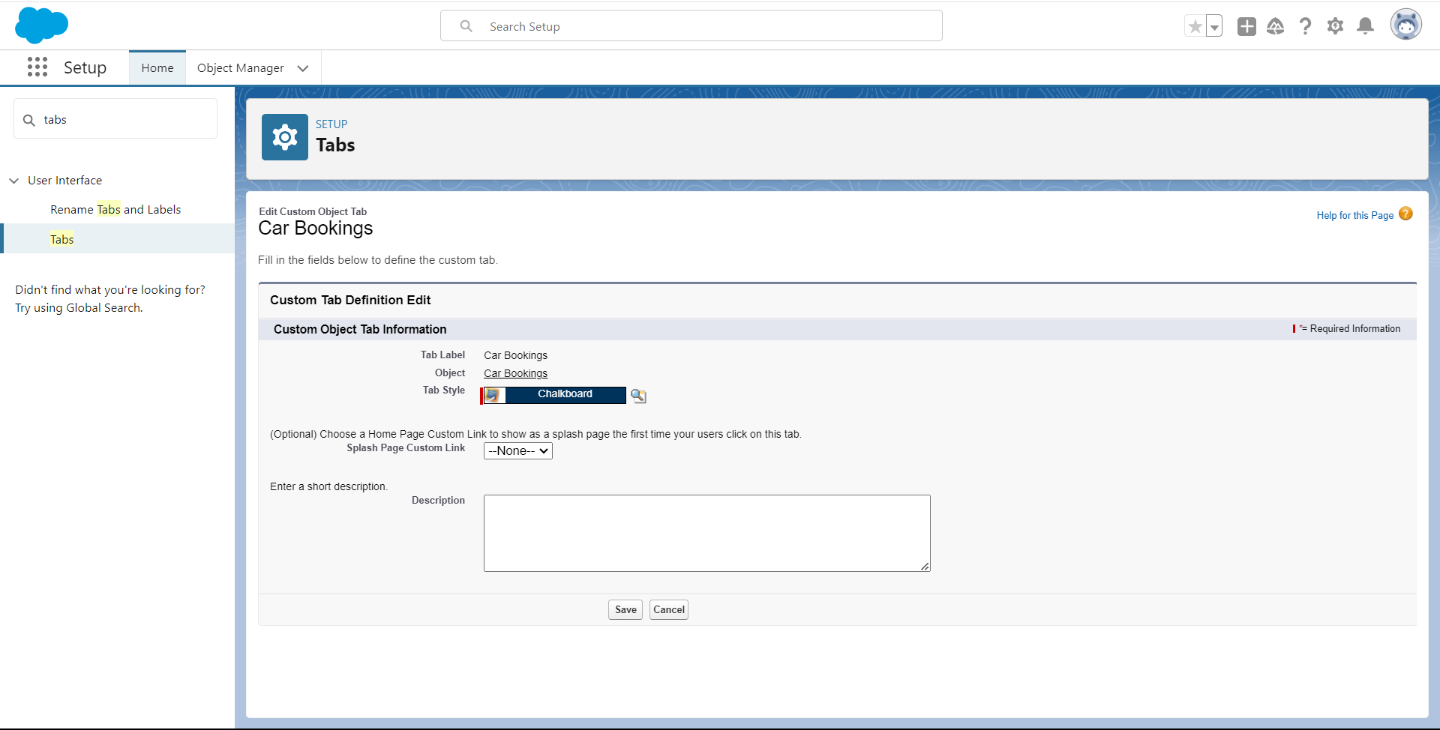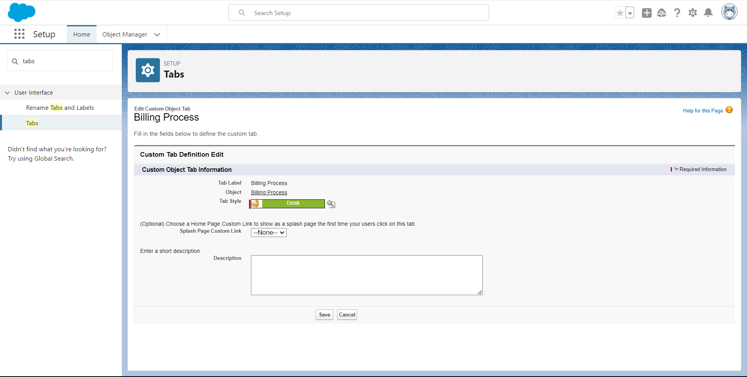

**Billing Process Tab**

**Total Cars Tab**

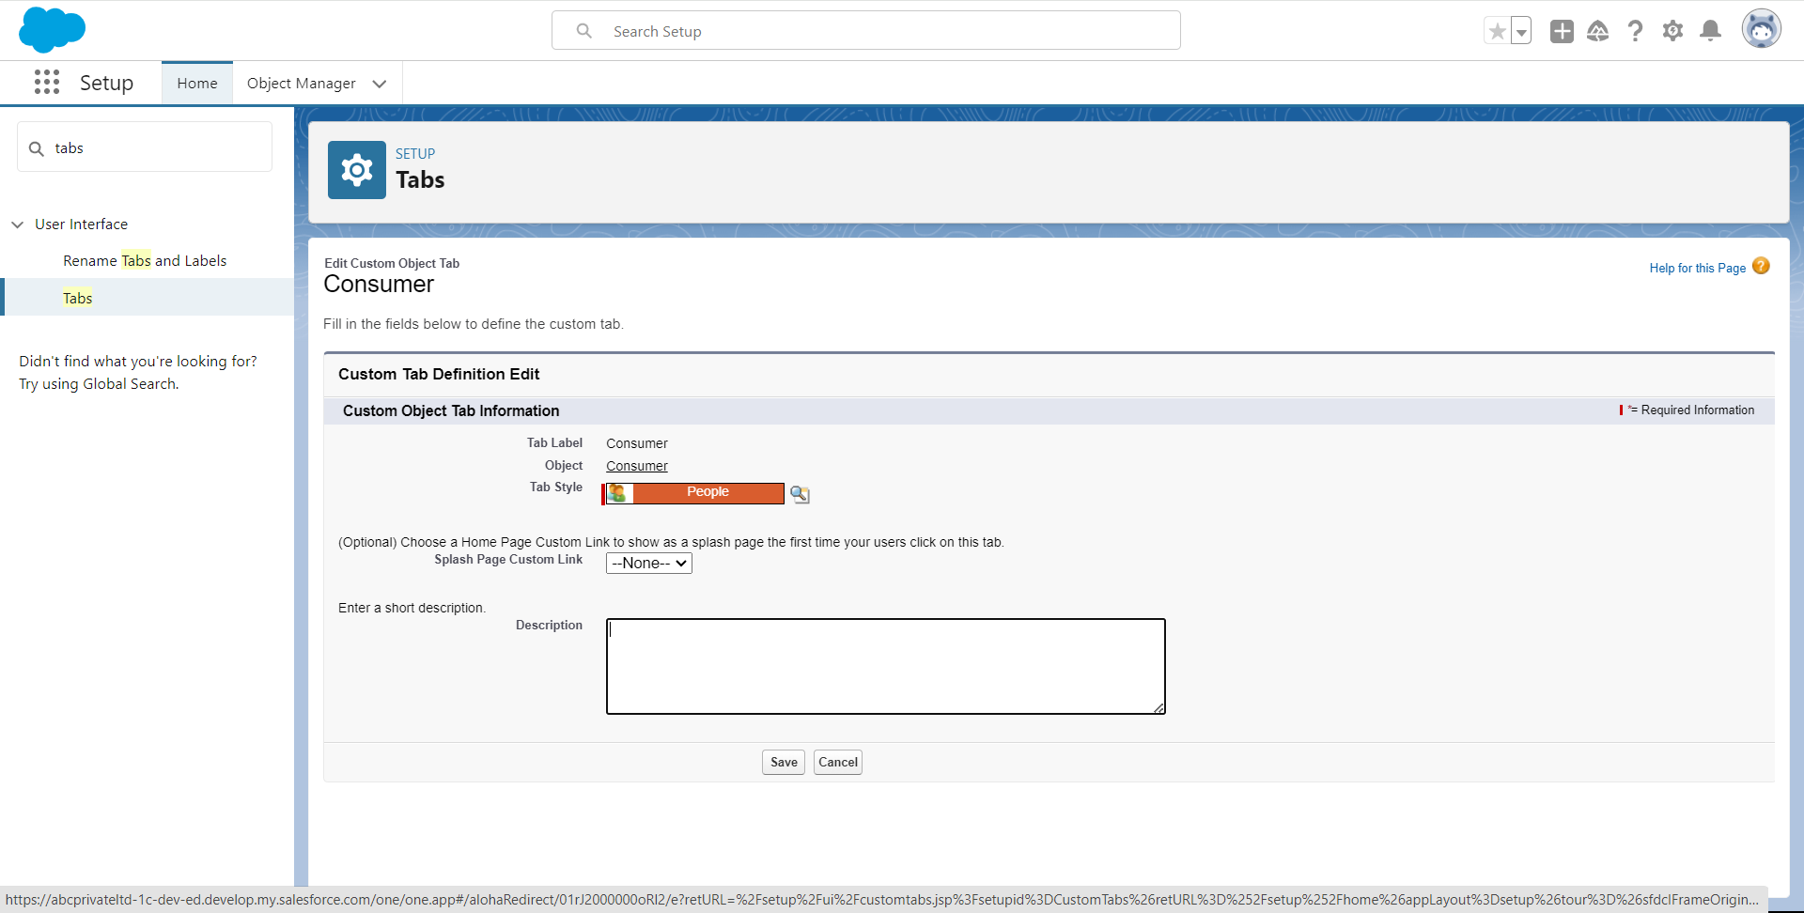

**Consumer Tab**



### **Create a Lightning App**

An app is a collection of items that work together to serve a particular function. In Lightning Experience, Lightning apps give your users access to sets of objects, tabs, and other items all in one convenient bundle in the navigation bar.

Lightning apps let you brand your apps with a custom color and logo. You can even include a utility bar and Lightning page tabs in your Lightning app. Members of your org can work more efficiently by easily switching between apps.

**Car Rentals Lightning App**

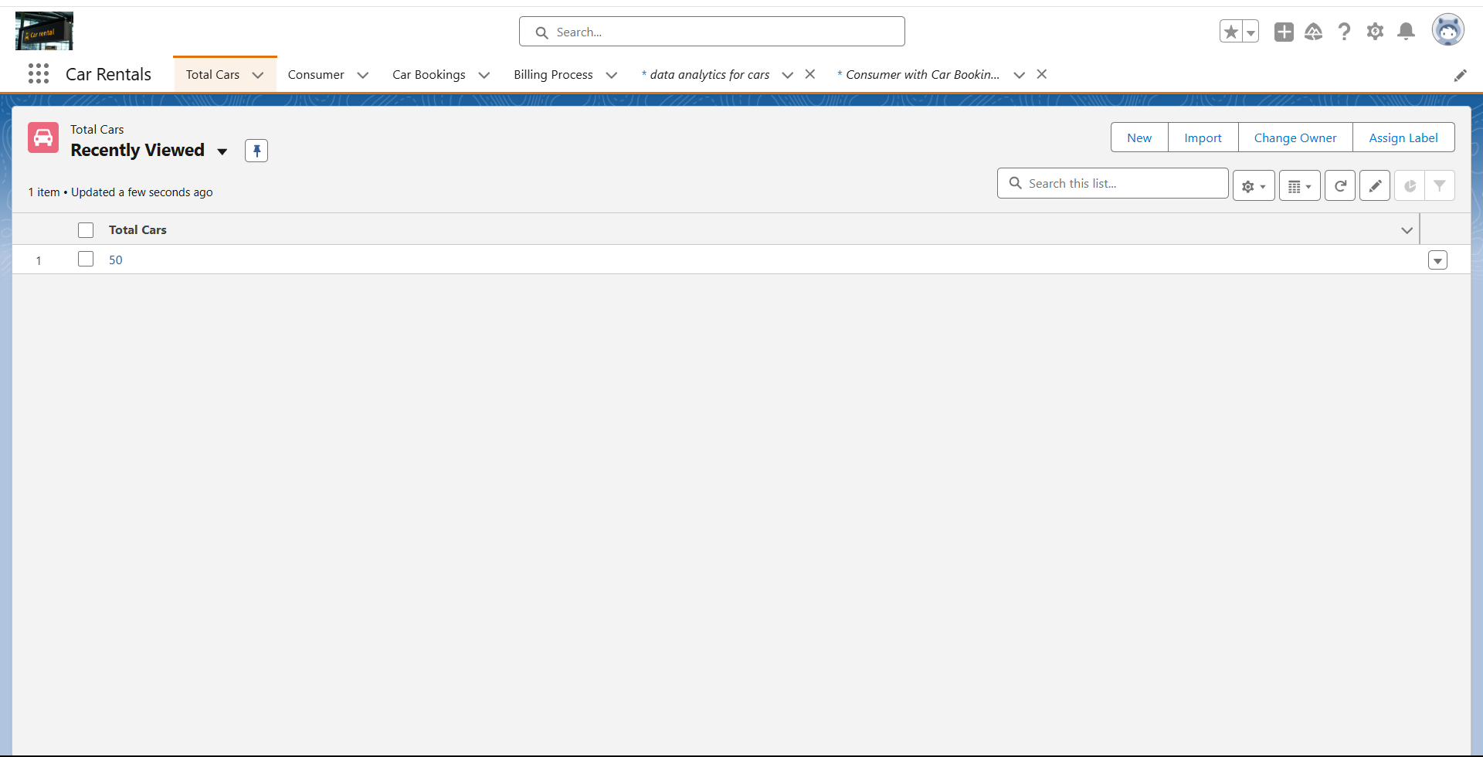

### **Fields**

When we talk about Salesforce, Fields represent the data stored in the columns of a relational database. It can also hold any valuable information that you require for a specific object. Hence, the overall searching, deletion, and editing of the records become simpler and quicker.

Types of Fields

1. Standard Fields
2. Custom Fields

Standard Fields:

As the name suggests, the Standard Fields are the predefined fields in Salesforce that perform a standard task. The main point is that you can’t simply delete a Standard Field until it is a non-required standard field. Otherwise, users have the option to delete them at any point from the application freely. Moreover, we have some fields that you will find common in every Salesforce application. They are,

>>Created By

>>Owner

>> Last Modified

>> Field Made During object Creation

Custom Fields:

On the other side of the coin, Custom Fields are highly flexible, and users can change them according to requirements. Moreover, each organizer or company can use them if necessary. It means you need not always include them in the records, unlike Standard fields. Hence, the final decision depends on the user, and he can add/remove Custom Fields of any given form.

### **Creating the field in consumer object**

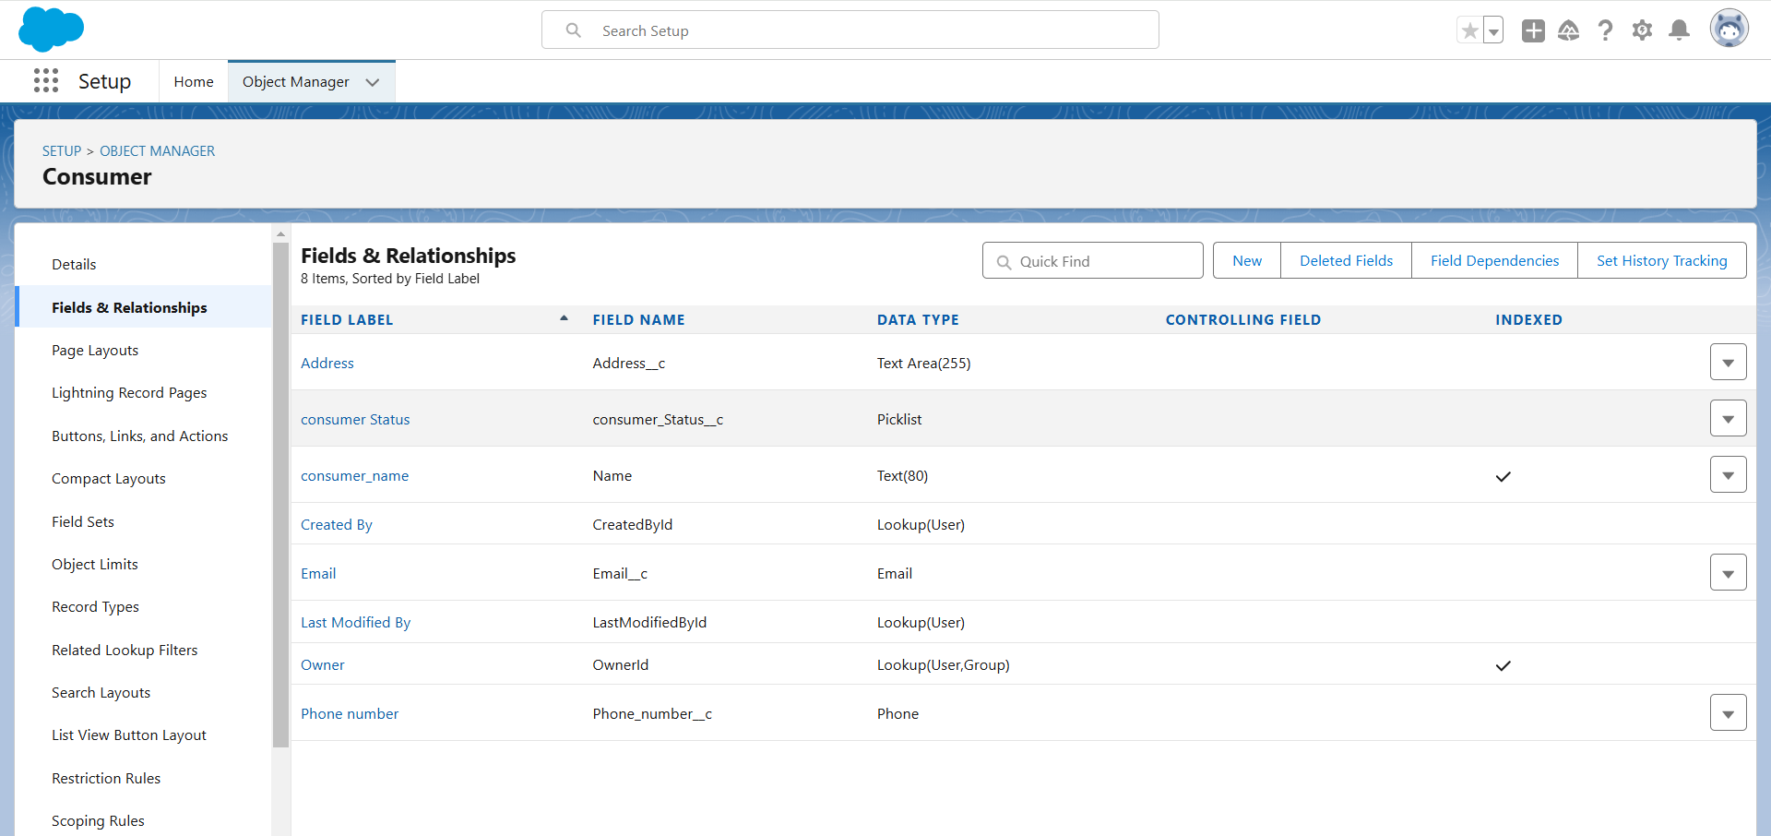

### 

### **Creating the field in Car Bookings object**

### **To Create a Fields & Relationship to an Car Booking Object**

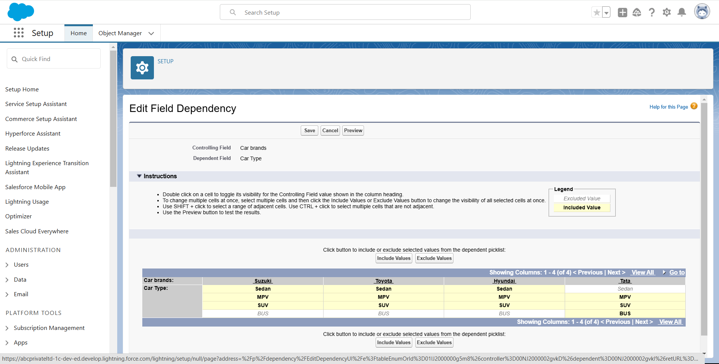

### 

### **Validation rule**

Validation rules are applied when a user tries to save a record and are used to check if the data meets specified criteria. If the criteria are not met, the validation rule triggers an error message and prevents the user from saving the record until the issues are resolved.

Improve the quality of your data using validation rules. Validation rules verify that the data a user enters in a record meets the standards you specify before the user can save the record. A validation rule can contain a formula or expression that evaluates the data in one or more fields and returns a value of “True” or “False”. Validation rules also include an error message to display to the user when the rule returns a value of “True” due to an invalid value.

### **Creating the validation rule for phone number field in consumer object**

1. Go to the setup page >> click on object manager >> From drop down click edit for consumer object.
2. Click on the validation rule >> click New.
3. Enter the Rule name as “Phonenumberoremailblankrule ”.
4. Enter the description as “phone number and email number should not be blank”.
5. Enter the formula as “OR( ISBLANK( phone_number__c ) , ISBLANK( email__c ) )” and check the syntax.

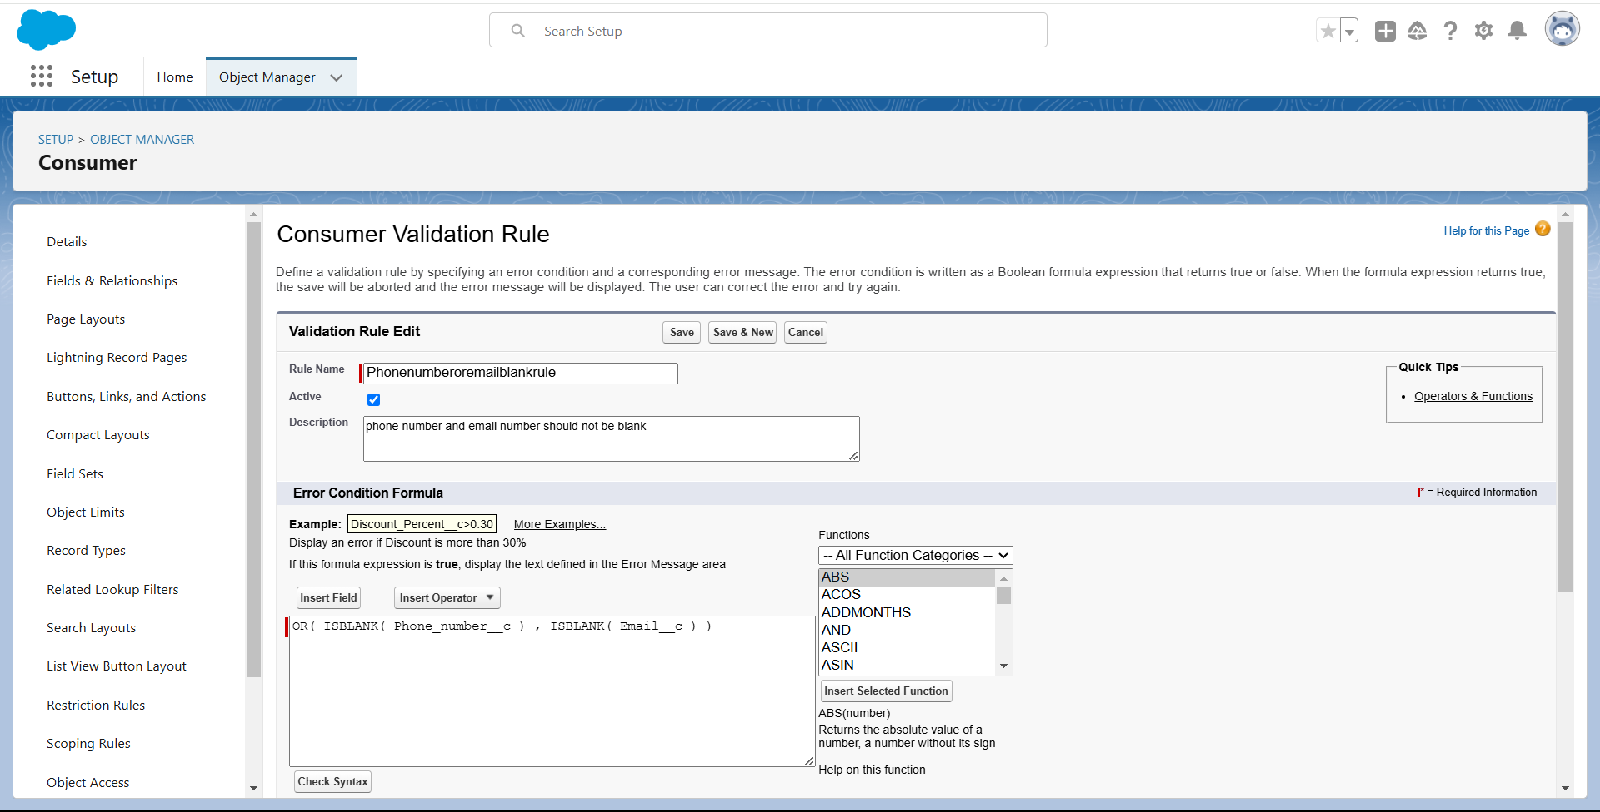

**Profiles**

A profile is a group/collection of settings and permissions that define what a user can do in salesforce. Profile controls “Object permissions, Field permissions, User permissions, Tab settings, App settings, Apex class access, Visualforce page access, Page layouts, Record Types, Login hours & Login IP ranges. You can define profiles by the user's job function. For example System Administrator, Developer, Sales Representative.

**Types of profiles in salesforce**

1. **Standard profiles:**

By default salesforce provides below standard profiles.

* Contract Manager
* Read Only
* Marketing User
* Solutions Manager
* Standard User
* System Administrator.

We cannot deleted standard ones

Each of these standard ones includes a default set of permissions for all of the standard objects available on the platform.

1. **Custom Profiles:**

Custom ones defined by us.

They can be deleted if there are no users assigned with that particular one.

### 

### 

### 

### 

### **owner Profile**

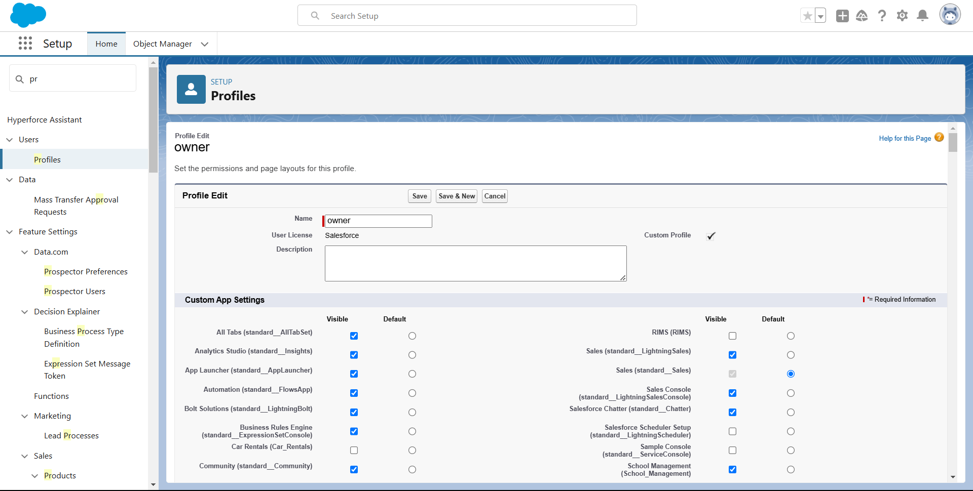

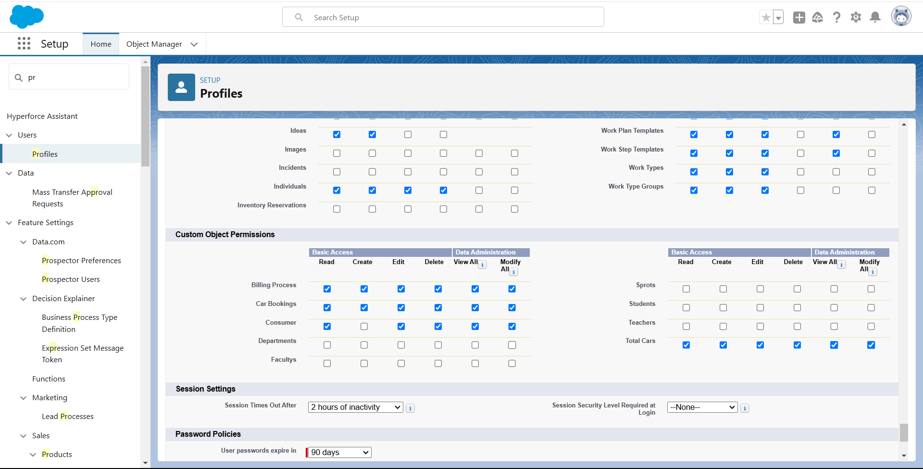

### 

### 

### 

### **Agent Profile**

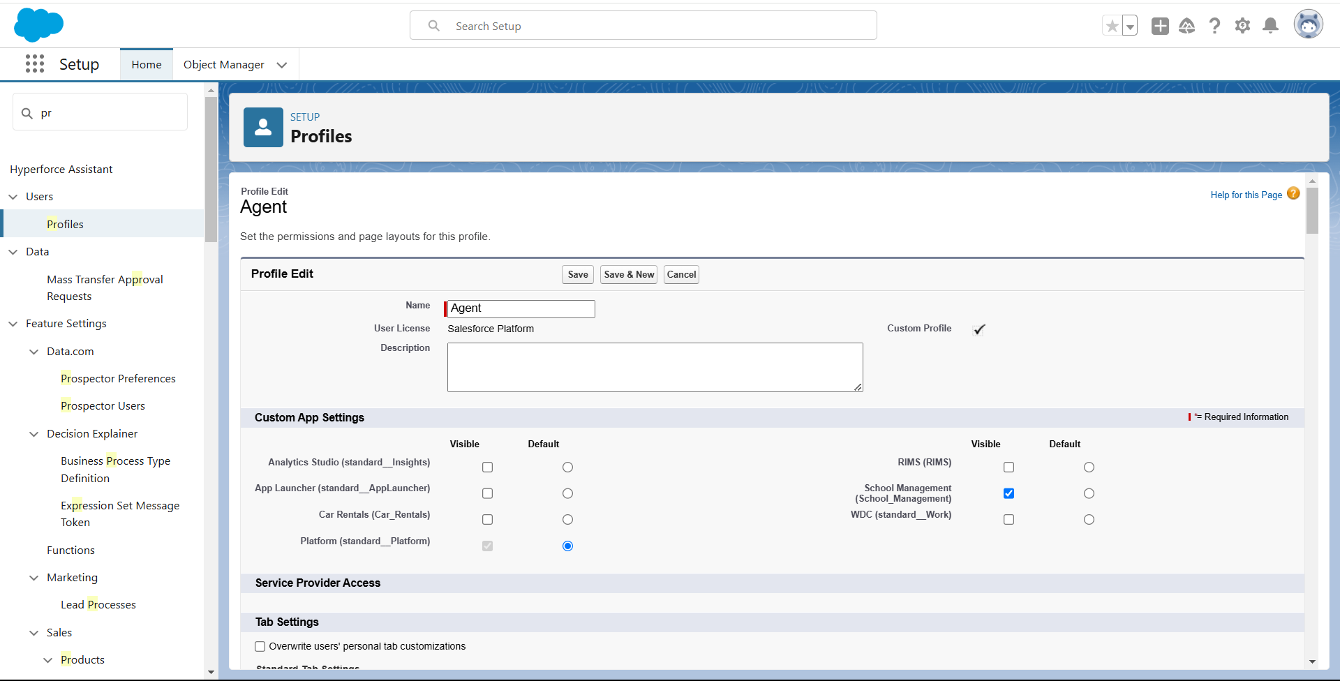

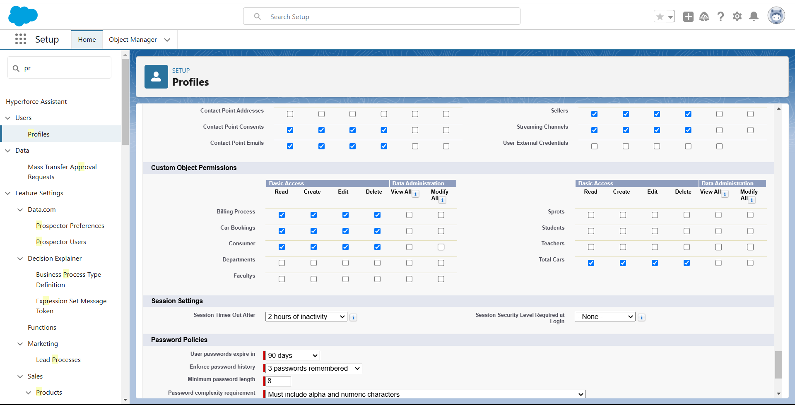

### **Roles and Hierarchy**

A role in Salesforce defines a user's visibility access at the record level. Roles may be used to specify the types of access that people in your Salesforce organization can have to data. Simply put, it describes what a user could see within the Salesforce organization.

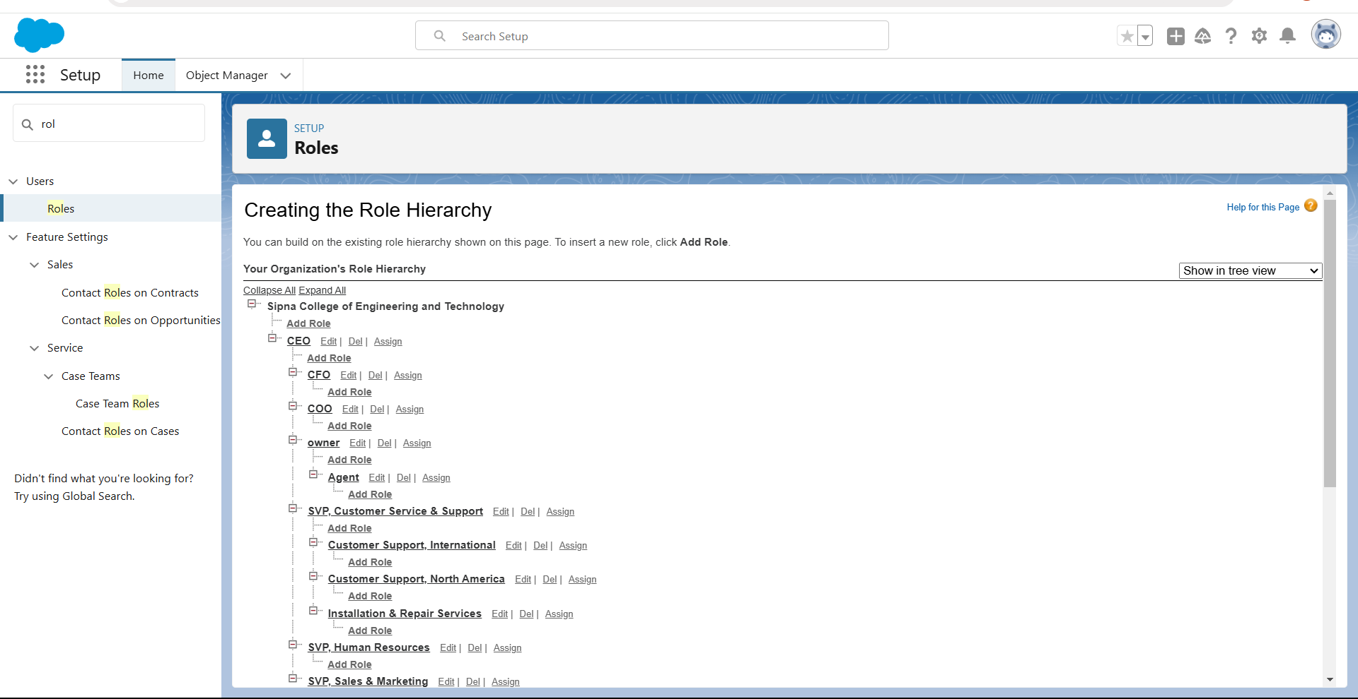

### **Flows**

### 

### **Create a Flow on Suzuki car**

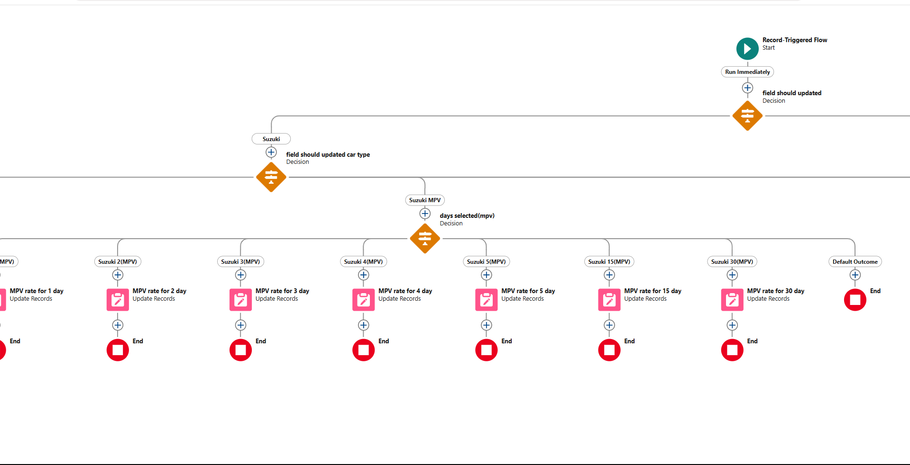

**Create flow for other cars same as Suzuki**

### **APEX**

## Apex OverView

Apex is a strongly typed, object-oriented programming language that allows developers to execute flow and transaction control statements on the Lightning platform server in conjunction with calls to the Lightning Platform? API. Using syntax that looks like Java and acts like database stored procedures, Apex enables developers to add business logic to most system events, including button clicks, related record updates, and Visualforce pages. Apex code can be initiated by Web service requests and from triggers on objects.

It is as similar as java i.e, it also supports OOP( Object oriented programming) like Classes, objects, methods.

## Creating Classes :

Apex classes are modeled on their counterparts in Java. You’ll define, instantiate, and extend classes, and you’ll work with interfaces, Apex class versions, properties, and other related class concepts.

* Class:  
  As in Java, you can create classes in Apex. A class is a template or blueprint from which objects are created. An object is an instance of a class.
* Object

Object is an instance of a class, where it can access all the properties that are present in a class i.e, variables and methods.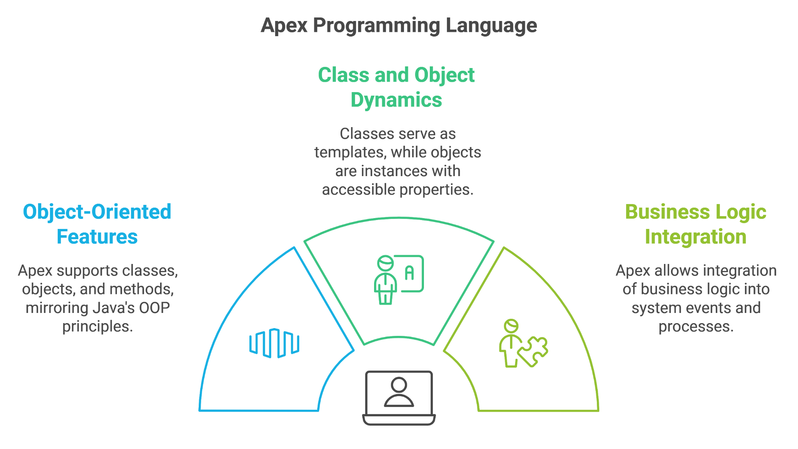

**CarBookingHandler.apex**

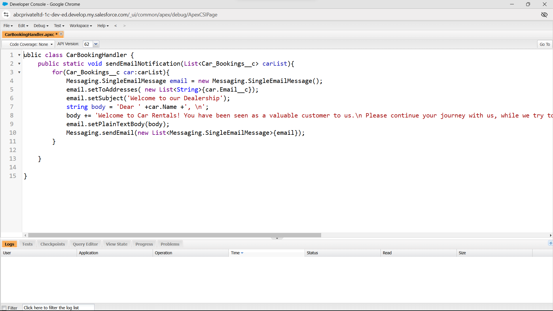

**CarBooking.apex**

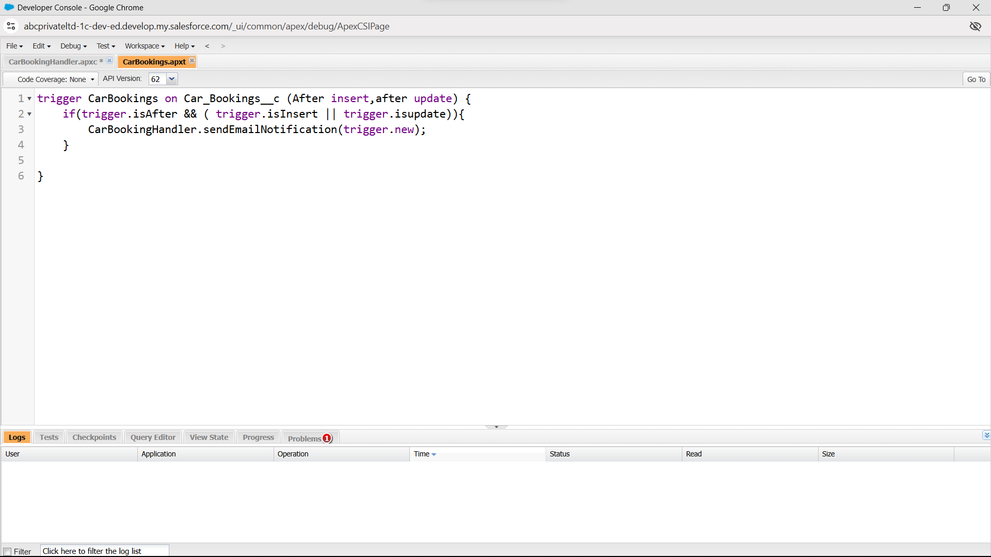

### **Dashboards**

Dashboards help you visually understand changing business conditions so you can make decisions based on the real-time data you’ve gathered with reports. Use dashboards to help users identify trends, sort out quantities, and measure the impact of their activities. Before building, reading, and sharing dashboards, review these dashboard basics.

# 

# 

# 

# 

# 

# 

# **Consumer with Car Bookings and Total Car**

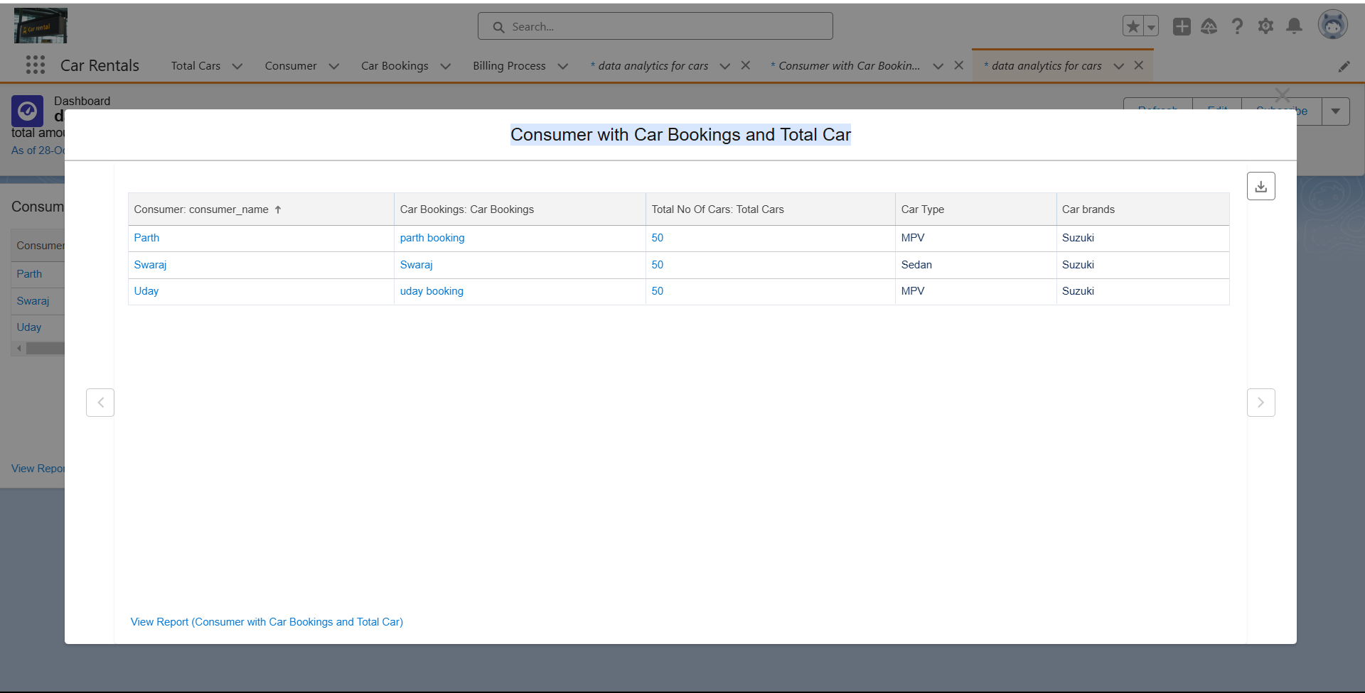

### **Conclusion**

This Salesforce-powered CRM application for car rentals offers a comprehensive solution for enhancing customer experience, optimizing operations, and driving business growth. By leveraging Salesforce’s robust capabilities such as Sales Cloud for lead management, Service Cloud for case resolution, Marketing Cloud for targeted communication, and Einstein Analytics for actionable insights the application empowers the rental business to deliver personalized, efficient, and data-driven services. The integration of automated processes, mobile accessibility, and AI-driven analytics not only streamlines daily operations but also builds stronger customer relationships, driving loyalty and repeat business. With these advanced features and tools, the CRM application sets a solid foundation for long-term success in the competitive car rental industry, meeting business goals while exceeding customer expectations.